Staff Survey Results – Active Start
What benefit(s) have you seen in your students since the Active Start program began?
(12 Responses)
Answer Choices – | Responses –
–  Increased happiness and well-being | 91.67%  11
–  Increased sense of love and belonging | 50.00%  6
–  Increased sense of community | 91.67%  11
–  Increased retention | 16.67%  2
–  Increased ability to focus | 66.67%  8
–  Decrease in anger or aggression | 8.33%  1
–  Decrease in impulsive decision making | 8.33%  1
–  Decrease in anxiety | 33.33%  4

How often have students arrived late for Active Start?
- Answered: 13
- Skipped: 0

Answer Choices – | Responses –
–  Never | 0.00%  0
–  Rarely | 7.69%  1
–  Sometimes | 61.54%  8
–  Often | 30.77%  4
–  Always | 0.00%  0
Total | 13
Comments:
Nothing, really. What can we do??
Not In a position to do so
Reviewed the importance of arriving on time with parents.
Mme Rioux and the office have gently reminded those by email or in person that school starts at 8h50.
See the data, question staff, remind staff to communicate with parents
Reminder to the parents.
Nothing in particular (sorry!)

Family Survey Results – Active Start
What benefit(s) have you seen in your child(ren) or heard about from your child(ren) since the Active Start program began?
- Answered: 49
- Skipped: 18

Answer Choices – | Responses –
–  Increased happiness | 44.90%  22
–  Increased sense of love and belonging | 18.37%  9
–  Increased sense of well-being | 34.69%  17
–  Increased sense of community | 55.10%  27
–  Better academic achievement | 10.20%  5
–  Decrease in anger or aggression | 6.12%  3
–  Decrease in impulsive decision making | 10.20%  5
–  Decrease in anxiety | 10.20%  5
Total Respondents: 49

Comments specific to question:
None - she walks to school usually anyways

No change not happy about it

haven't noticed a change

I'm not sure I can relate any particular attitudes to the Active Start program. Sorry.

Enjoying excersize

doesn't like active start outdoors in the winter, likes the indoor zumba

Being more alert throughout the day. Increase to physical fitness. Enjoying the outdoors.

None

My son doesn't like it he feels so cold

no change, no mention by child

Preference is indoor active start over the winter months

He hasn't talked about active start

Not seen or heard of any particular benefits.

Building up the friendship

none

None- she does not enjoy it

Increased fitness, more friends

None of the above

General Comments:

I think it's a great idea and I hope that it last all year.

My son, who is very active, enjoys have more physical activity during his day.

Difficult for large classes to actually "work out" and get moving. Kids seem to enjoy it.

Both kids look forward to active start everyday!

I would like to see more fun programming being implemented in the outdoor active start. Shake it up a little. I know it is winter now so this is not an issue as of right now. But in the fall it would have been fun to see the two fields being used and some fun activities to get their heart rates up. relay races, zumba or something? Mme J must have some suggestions?

I think it is a great idea and would support its continuance. I suspect the teachers would be the best judge of specific behavioural benefits.

I just wish the school would let the kids play outside at recess and lunch hour and if it's "too cold" then let the kids go in and out at will and who cares if the floors get dirty -- it's a school. The floors SHOULD get dirty. The state of the floors should not factor into the equation at all.

Please continue - it is a wonderful way to start the day!
Excellent idea to keep the kids active!

I love and support the new activity, my child resists it...I will try to attend the next couple of weeks...

I love active start and I hope that you continue the program.

He seems to look forward to it, particularly outdoors.

Weather permitted, I think active start is important for student health. As much physical activity in a day as possible is good.

An absolutely terrific initiative. Daily exercise is crucial and this is good training for our children to learn to include as part of their daily ritual. Bravo ETP.

"I feel relaxed, calm and ready to learn" is what my gr 4 daughter said.

I love it. It's a great idea

Our kids are more positive about going to school on the days they have Active Start and relish the extra time with their friends.

Great idea, love it!

I think it's great they do active start every morning. It gets the blood flowing and they are better prepared for the day. It is also a great way to encourage participation in group activities. I think it's fabulous!

We walk to and from school most days. I think it would be great if the kids could do something that would get their heart rates up more for active start.

This is a wonderful way for all to start the day. Children gain a new sense of bonding and excited about exercise. Please continue this program.

I feel they could spend the time on spelling or math. It's not a bad idea but there are so many other things.

I think during cold days it's so difficult for my child to walk in cold and he usually feels sick

Although they are not able to articulate it, my girls do very well with the extra fresh air and exercise to start the day. We think this is a great program

My energetic daughter loves it! Loves interacting with all grade levels.

My daughter says she feels calm, but does not like active start because in the winter, boots and coats are heavy and sun is hot on head. She likes active start indoors.

I really haven't seen any real change in my kids though I think that the school should still continue to do this as it's important to promote healthy lifestyle

I think it's a great way to start your school day.

My child has not mentioned anything about Active Start. I'm not sure if it is affecting him at all.
I do not have the sense that my children like or dislike Active Start - it does not matter to them whether it continues.

The kids love it (enjoy inside more during winter, that is probably because they walk home outside and feel they have enough)

My daughter looks forward to Active Start and, in particular, to doing it outdoors. Thanks for starting up the program.

Has this been shown in studies to be of proven benefit? I'd rather have them learning math and reading skills as they already have gym every school day except one.

Good idea. Keep it up. Make it vigorous.

My child does not like active start and she complains often about having to run in bad weather first thing in the morning.

Kids don't like going outside during winter for active start, they always moan and groan on the days it's outside.

My child likes this start to the day, but I haven't noticed any significant change.

Provide an overview of what active start is on the ETP website.

Please keep it up! We as a society need more exercise, and this is a great way to start and instill this from kindergarten.

It's a great program. Kids need more physical activity!

My child always looks forward to active start and I think getting kids outside at the start of the day is an amazing idea and I hope it keeps up!!

My child (in grade 6) doesn't appear to be enjoying Active Start, particularly on cold days. She much prefers the indoor activities which to her are more fun that running outdoors.

Analysis of 42 Comments:
71% Positive 14% Negative 9.5% Suggestions 5% Neutral 2.4% Other

Student Survey Results – Active Start
Do you like Active Start?
Yes | 36%
It’s Ok | 49%
No | 15%
Comments were provided by grade 3 and grade 4/5. Most of the comments reflected the student’s opinions that they don’t enjoy Active Start outside in the winter because it is too cold and too hard to walk and run in the snow. This was represented in 63% of the comments. Other comments stated that students wish that the indoor part was more active and had more variety. (21%)
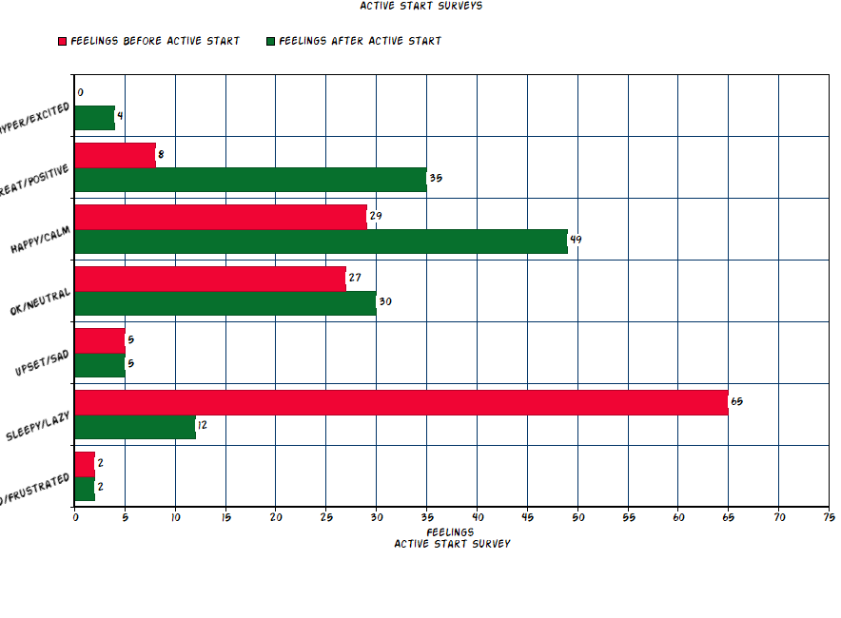
Feeling | Before A.S. (red) | After A.S. (green)
Irritated/Frustrated | 1% | 1%
Sleepy-Lazy | 48% | 9%
Upset/Sad | 4% | 4%
OK/Neutral | 20% | 22%
Happy/Calm | 21% | 36%
Great/Positive | 6% | 26%
Hyper/Excited | 0% | 3%

